what affects inspection quality? insights from a Jordan Business survey

Adit Mahmood

November 10, 2020

What Affects Inspection Quality: Insights from a Jordan business survey

*By: Adit Mahmood*

## Executive Summary

The IFC developed the “Inspection Reform II” project to ensure high quality in future business inspections in Jordan. There are several reasons why the quality of an inspection could be in question. The three biggest ones are that the inspectors are biased, there is an unequal distribution between surprise and planned visits, and there are inspections that are either excessive or redundant. Other factors affecting inspection quality include the level of awareness that the businesses and/or inspectors have about inspection procedures or legal rights of the businesses inspected, and whether there is lack of planning or coordination between different inspection agencies. The latter could be an intriguing factor to evaluate as companies could become more disgruntled as the number of inspections, surprise or not, increases over time. These issues are confirmed by a baseline survey of Jordanian businesses which found that of the surveyed businesses:

* Only 62% are aware of the inspection process and technical requirements.
* Only 51% are satisfied with inspector behavior.
* Only 19% knew beforehand the purpose of the inspection.
* 42% think that they have suffered unfair inspection decisions.

A recently completed ex-post evaluation study aimed to assess the results of the IFC advisory project, Jordan Inspection Reforms II project, i.e., whether the reforms supported by the project helped improve the performance of the inspections and determine areas where further improvement is needed. It showed improvement in most aspects of the inspection process but there are areas where more work is needed.

This paper takes the analysis a step further and examines potential relationships between the various factors involved through logistic regressions. This exercise used two sets of data to determine trends that potentially illustrate whether those concerns listed above are legitimate or not. The exercise involved a linear regression on each data model to determine the best models that could be used in a logistic regression. Then, a logistic regression was used to reveal the best model to base predictions on. The final step was to generate those predictions and compare it to the actual distribution. This would test the reliability of the model and answer whether the previous concerns were legitimate or not.

The analysis used the current level of satisfaction of businesses with the inspector’s performance and conduct, and their perception of the change in the inspection process in recent years, as the dependent variables in one study that covered only inspections conducted by the Greater Amman Municipality (GAM). This analysis showed that business opinions on inspection quality can be improved if more attention is paid to improving inspector conduct during inspections and reducing the average number of inspection visits. The analysis also showed that inspector conduct, in turn, is affected by the inspectors’ level of awareness about the technical aspects of inspections. The other study, covering all inspections, used business perception of the fairness of the inspector’s decisions, and their overall performance and conduct during inspections, as dependent variables. This analysis showed that best way to increase the fairness of inspector decisions is to look at the performance and conduct of the inspector and the number of visits by them. It also showed that performance of an inspector during the inspection could be improved by looking at the inspector’s awareness of the technical aspects of inspections and business awareness of their legal rights.

# What Affects Inspection Quality: Insights from a Jordan business survey

1. Introduction

### Problems with the inspection regime in Jordan

The private sector in Jordan faced many challenges from the inspection regime. These were concerning enough to warrant a large-scale inspection reform project, supported by the IFC. These reforms were made necessary because the bulk of prior attention was on a smaller scale intervention by the IFC from 2007-2009. More recently, the Jordanian government became interested in wider-scale reform that corrects overarching issues and reforms all inspections. IFC supported these reforms through the Inspection Reform II project, implemented between January 2014 – December 2017.

IFC analysts have discovered that inspection reform must deal with many potential challenges. These challenges can be categorized into several groups: duplication of inspections, contradictory procedures and requirements, inconsistent level of preparation among inspectors, questionable transparency, potential bias, and the lack of legal and technical awareness among businesses and inspectors.

These problems are, in turn, created by deeper institutional and capacity problems. These include lack of coordination and information sharing among inspectorates, inadequate documentation and dissemination of inspection related information to businesses, no comprehensive national database with information about economic activities, lack of risk rating tools, inadequately trained and skilled inspectors, and absence of proper and fair appeal mechanisms for the private sector to file complaints.

These issues create a poor opinion about the inspection process among businesses. For example, lack of coordination and duplication of inspections can dissatisfaction among businesses who believe that inspections are a waste of time and source of harassment. A baseline survey of Jordanian businesses carried out in 2011 found that of the surveyed businesses:

* Only 62% are aware of the inspection process and technical requirements.
* Only 51% are satisfied with inspector behavior.
* Only 19% knew beforehand the purpose of the inspection.
* As many as 42% think that they have suffered unfair inspection decisions.

### How the IFC inspection reform project tried to address these issues

The IFC Inspection Reform II project aimed to help the government carry out a set of reform actions to address the challenges mentioned above. The project team studied the most common reform models in more than 25 countries to help identify the best national inspection reform model that the government may adopt. The specific actions supported by the project included the following:

1. Establish a database containing information on businesses subject to inspection to allow for inter-inspectorate communications. This was expected to reduce overlap and duplication between inspectorates and thus reduce the average number of inspections.
2. Establish a risk assessment framework that helps establish goals, key performance indicators, and inspection plans for each inspection area. It is intended to help decide which enterprises will be inspected, and how frequently, depending on their risk classification.
3. Collect, document, and disseminate information about the legal and technical requirements for each inspection. This step is important because if businesses are aware of the requirements and their obligations, this may reduce uncertainty and increase their compliance. The project did not create new standards, but instead, made information about existing standards widely available, and reminded both parties of the guidelines at the start of an inspection.
4. Build capacity, knowledge, and communication skills of the inspectors so that they know what needs to be done during the inspection visit and how to conduct themselves with the business owners and employees. Increased awareness of inspectors is expected to reduce bias or preferential treatment and thus increase business satisfaction with the inspection.
5. Establish a schedule for visits and promote announced visits. Develop and adopt standard operating procedures, guidelines, and checklist to improve the inspection process.

## II. Project results

The IFC Inspection Reform II project looked at several potential factors that could hinder improvement in the quality and business perception of business inspections in Jordan. A study was carried out in 2011 to develop a baseline for future studies of inspection quality.[1] This study included several focus group discussions and a survey of businesses. This allows a comparison over time. The IFC project team used the results from a 2011 baseline study to create new objectives that would guide business inspection reforms.

An ex-post study[2] was carried out in 2020 to assess the results of the IFC project. It allows a comparison of results against the target levels to reach conclusions about the effectiveness of the project, i.e., whether the reforms supported by the project helped improve the performance of the inspections, and determine areas where further improvement is needed. This study was designed to assess where the government and private sector is getting it right when it comes to inspections and where they can improve.

This ex-post study used qualitative and quantitative data gathering methods to assess the quality of inspections and satisfaction of the private sector with the inspection process. The study team conducted desk research, interviews with the IFC project team, surveys of businesses inspected and Key Informant Interviews (KII). 155 businesses from 12 sectors were surveyed using a structured questionnaire. The sample was selected from a list of businesses maintained by the firm carrying out the study along with some businesses surveyed during the baseline study.

The questions covered the awareness level of businesses about inspection procedures and their legal rights and obligations, inspector awareness of the technical aspects of inspection, the time and resources spent by businesses during each inspection, the distribution of surprise/planned visits, and whether the quality of the inspections changed over time. The surveys were taking place concurrently with Key Informant Interviews (KII) which were designed to create a qualitative understanding of the inspection process in different agencies. The interviews covered 17 government officials from different ministries and inspectorates and 30 businesses from 13 sectors.

The findings have been reported in two formats in the ex-post study report: a qualitative discussion based on the KIIs and quantitative tables based on the survey data. The quantitative results are simple summary statistics showing percentage distribution and averages. These are presented below.

### Business opinions about the change in inspection processes over time

Business opinions expressed in the 2020 survey are better than those expressed in the 2011 baseline survey. These also exceed the targets set by the project. Thus, the project shows good results. On average, results exceeded the baseline values by 13-46 percentage points (Figure 1). The biggest improvement is in the proportion of businesses that said that they were aware of their legal rights (a 46 percentage point increase), while the smallest increase in the proportion of businesses who were informed ahead of the inspection goals and purpose (a 13 percentage point increase).

The targets were achieved in all cases (in one case, no target was set) with the actuals exceeding target values by about 15-35 percentage points. However, the achievement was not the same for all aspects of inspection. The biggest increase is in the proportion of businesses who are aware of their legal rights and the smallest is in the proportion of businesses who believe inspectors are aware of the technical aspects of the inspection. Overall, the results suggest that various aspects of inspection procedures including each party’s awareness of the legal and inspection procedures as well as the satisfaction of the businesses about the fairness of inspection increased significantly.

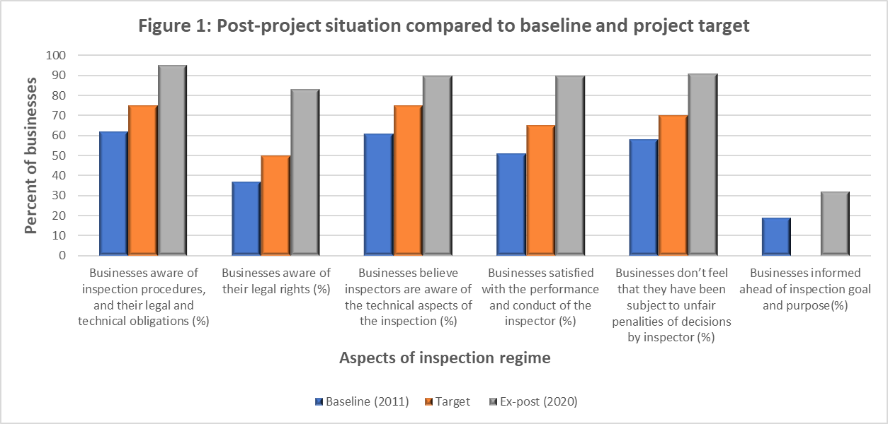

The 2020 survey also asked businesses directly if they thought the situation has improved over the past few years (Figure 2). In some areas, the relevant issues and concerns that businesses felt were clearly starting to resolve over time and the confidence of the businesses on the inspectors has improved. The biggest sign of this is found in the concern that inspectors overly punish the businesses for weaknesses found in the inspection. 83% of the businesses felt that the fairness of inspection decisions has improved in the recent past. This variable is an important proxy for inspection quality and is used as a dependent variable in the statistical analysis reported later.

Two other areas with significant improvement relate to business awareness. About two-thirds of businesses felt that their awareness of legal rights, and inspection procedures and their obligations have increased over time. Responses to other questions, such as the one about inspector’s awareness and conduct were more evenly distributed. More work is needed on areas such as inspector awareness of the technical aspects of inspection, performance and conduct of inspectors and frequency of inspection visits. In these areas, the majority of businesses did not report an improvement.

### Differences between inspection agencies

The 2020 survey collected data on business perceptions disaggregated by different ministries and agencies carrying out inspections. The results are shown through a box and whiskers plot (Figure 3). These data do not show much variation across agencies in the degree of improvement except in two areas, i.e., provision of prior information to businesses on the goals and processes of inspection, and business perceptions on whether the inspection process has improved overall. The findings suggest that the number of surprise visits was either not addressed or was not impacted by other parts of the inspection. As for the remaining five inspection concerns analyzed, no significant differences were observed. Unlike the two concerns at the bottom, the five experienced similar and significant change.

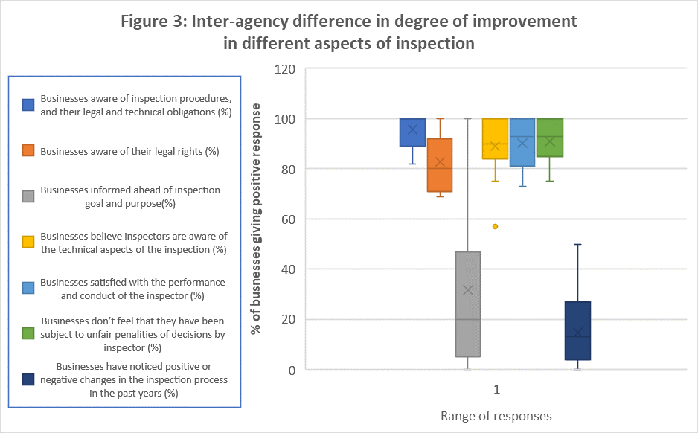

This study showed that the reforms did have an impact as most business felt like the inspector’s decisions grew more fairer over time. However, there were some other questions that presented findings that were more counter intuitive. Therefore, the next step is to use regression and machine learning to determine the best factors to use to increase areas such as fairness of the inspection.

## III. Analysis of factors affecting inspection quality: the approach

### Introduction

The ex-post evaluation study left open the possibility of further analysis that could be done with the data to determine correlation, and maybe even apply machine learning techniques to predict future responses. These analytic techniques could expand the scope of the analysis. This section explains the approach taken for such an analysis while Section IV provides the findings from such an analysis and provides richer insights about the inspection process in Jordan.

Two separate analytic exercises were carried out based on the survey of Jordanian businesses done for the ex-post evaluation study. This survey collected perception data on the experience of businesses with government inspectors. The first analysis covers only the General Amman Municipality (GAM) based inspections. The GAM data is singled out because GAM conducted the most inspections by far and, thus, deserved to be examined through a separate exercise. The other analysis was based on the aggregate dataset of all inspected businesses covered by the survey. The GAM data largely provides the current, i.e., 2019, picture about different aspects of the inspection process. The aggregate data capture business perceptions of changes over time.

### Methodological considerations

Several methodological considerations must be taken care of to get results that provide valuable insights. The important questions are: a) what is the structure of the study in relation to its objectives?; b) what kind of data should be collected, e.g. quantitative or qualitative?; c) whether the sample size and sampling method is appropriate?; d) whether the data collected is relevant and free of bias as much as possible?; and e) whether the study covers one period or multiple periods?

### Data and logical framework

The quantitative data collected through the survey were of three types: ordinal results that captured perceptions of change over time, binary results that were yes or no, and discrete numbers that described the frequency of visits and number of employees involved. The study was not longitudinal because the data were collected during one period. However, some questions captured changes over time.

The GAM dataset contained several factors that may explain the quality of inspections:

* the average number of inspection visits in 2019
* number of concerned employees involved in the inspection
* the time spent by the employees in the inspections
* whether the business was aware of inspection procedures and their legal and technical obligations
* whether they were aware of their legal rights
* whether the inspection was a surprise visit
* whether the inspector was aware of the technical aspects of the inspection; and
* any signs of inspector bias (i.e., whether the businesses were subject to any unfair penalties or decisions by the inspector in 2019).

These were treated as independent variables in the analysis. While the first three variables were discrete numbers the other five were binary in nature with Yes/No as the responses.

The dependent variables which reflected the quality of inspections were whether:

* the business was satisfied with the inspector’s performance and conduct, and
* the business perception on whether the inspection process had improved or not in the recent past.

The first dependent variable was binary with Yes/No responses. The second was ordinal, with a score of 1 if the quality of the process had declined, 2 if it had remained the same and 3 if it had improved.

The aggregate dataset, i.e., dataset on all inspections, also had several potentially significant factors, which were defined as changes in the business awareness of their legal rights, and of inspection procedures and their obligations, the inspector’s awareness of the technical aspects of inspection, and the frequency and duplication of inspection visits. The two variables which were a proxy for inspection quality were inspector performance and conduct during the inspection, and the perceived fairness of their decisions. The two models used to analyze the aggregate dataset used these two as dependent variables. All variables were ordinal in nature, with a score of 1 if the quality of the process had declined, 2 if it had remained the same and 3 if it had improved.

### Analytic approach

Correlation analysis

First, a set of correlation analysis was conducted to examine the relationships between the factors in both datasets (*Figures A1 and A2 in Appendix)*, with a correlation coefficient less than -0.70 or more than 0.70 implying significant correlation. The GAM dataset revealed slightly more positive relationships than negative ones. The only pair of variables that had a significant degree of correlation was the one between the average number of inspection visits and amount of employee time spent on inspections (0.71). The next potential strong relationships between variables was between the business awareness of their legal rights, and their awareness of inspection procedures and their obligations (0.66) and the inspector awareness of technical aspects, and business satisfaction with inspections (0.50).

For the aggregate dataset, there were no negative relationships between factors. The strongest relationship was between the changes in inspector awareness of the technical aspects of inspections and changes in their performance and conduct (0.76). The next two strongest ones were between changes in the business awareness of their legal rights, and changes in business awareness of inspection procedures and their obligations (0.68), and changes in inspector’s performance and conduct, and frequency of inspections with higher score implying less frequent inspections (0.51).

Model selection

The “all best subsets” command in R was used to find the three best models to analyze via a logistic regression. Although there were many independent variables or predictors to choose from, it is good if the model is parsimonious, i.e., does not have too many predictors. The criteria used to select the predictors to include in the model were the highest adjusted R square figures and the lowest scores on the Akaike Information Criteria (AIC), Bayesian Information Criteria (BIC) and Amemiya Prediction Criteria (APC).

Logistic regression

The logistic regression used the p-value of each factor to determine which model should be the best for the prediction stage. The best prediction model was always the one where all p-values were less than 0.05. Once the best logistic regression model was chosen, a series of predictions were generated and compared to the actual data to check for reliability of the model chosen.

## IV. What factors affect inspection quality

Model selection  
The results of the model selection exercise are summarized below.

**Table 1: Models Chosen**

|  |  |  |
| --- | --- | --- |
| **Dependent Variables** | **Independent Variables** | **Dataset** |
| Change in inspection process over time | Average number of inspection visits + Satisfaction with inspector’s performance and conduct | GAM Model 1 |
| Satisfaction with inspector’s performance and conduct | Employee working time spent on inspections + Inspector awareness of technical aspects of inspection | GAM Model 2 |
| Fairness of inspection decisions | Satisfaction with inspector’s performance and conduct + Frequency of inspection visits | Aggregate Model 1 |
| Satisfaction of inspector’s performance and conduct | Business awareness of their legal rights + Business awareness of inspection procedures and their obligations | Aggregate Model 2 |

### Analysis of GAM data

### Model 1

In this model, the dependent variable was the perceived change in the inspection process over the past few years. Thus, while the dependent variable in Model 2 captures business satisfaction with the inspection process at one point in time, i.e., at the time of the survey, this variable captures perceptions of change over time. This variable had three possible values: 1 (negative, i.e., worsening of the process), 2 (neutral, i.e., no change), 3 (positive, i.e., improvement). This model, which was identified through the model selection process explained above, included, as independent variables, the average number of visits and whether the businesses were satisfied with the inspection (*Figure A3 in Appendix)*.

The logistic regression (Figure 4*)* showed that there was an indirect relationship between the change of opinion between inspections and the average number of visits (coefficient value of -0.02; significant at the 90% level), and a direct relationship with business satisfaction with the performance and conduct of the inspectors (coefficient value of 0.7821; significant at the 99.9% level).

This model is quite accurate (*Figure A4 in Appendix)*. The prediction model showed that 78 businesses felt that the current inspection did not change from the previous one. This is similar to the actual dataset, where 79 businesses did not feel that anything changed.

**Figure 4: Results of Logistic Regression using GAM data: Model 1**

### Model 2

Given the high level of significance of the variable “business satisfaction with the performance and conduct of the inspectors”, the second model selection exercise on the GAM dataset focused on this variable. The exercise showed that using a logistic regression with the “total employee working time during inspections” and “inspector awareness of the technical and scientific aspects of inspections” would be the best model to accurately predict the level of satisfaction that the business had about the inspector’s performance and conduct (*Figure A5 in Appendix)*.

Two other models also scored well on the model selection criteria, i.e., had high adjusted R squared score as well as low AIC, BIC, and APC. The following independent variables were included in these two models: a) total employee time spent on inspections, the inspector awareness, and the business awareness of inspection procedures and their obligations; and b) total employee time spent on inspections, the inspector awareness, the business awareness of its legal rights, and the business awareness of inspection procedures and their obligations.

For the best model, all the p-values were significant (Figure 5), and it had a low AIC value of 90.319. As shown in Figure 5 below, this logistic regression indicates that the level of business satisfaction with the inspector performance and conduct improves significantly with improvements in inspector awareness of the technical aspects of the inspection process (at 99.9% level of significance) and improvement (i.e. reduction) in the employee time spent in dealing with inspections (at 95% level of significance).

This model is also accurate enough to predict the satisfaction of future inspections (*Figure A6 in Appendix)*. The predicted number of satisfied businesses is 85, which is close to the actual data that revealed that 81 businesses were happy and 21 were not.

**Figure 5: Results of Logistic Regression using GAM data: Model 2**

### Aggregate inspection data

### Model 1

The fairness of the inspection[3] is used as the dependent variable in the first model that analyzed the aggregate data (*Figure A7 in Appendix)*. Multiple analysis revealed that the best logistic model to analyze the fairness of the inspection as well as the right model to base predictions on was the one where the inspector’s performance and conduct during the inspection and the frequency of the inspections were the independent variables (Figure 6). Unlike the GAM datasets, this model is not accurate as the model predicts that there would be 88 inspections where the fairness of inspection decisions had improved (*Figure A8 in Appendix)* while the actual dataset showed improvement in 128 cases.

**Figure 6: Results of Logistic Regression using aggregate data: Model 1**

### Model 2

The 2nd model focused on perceptions of changes in the performance and conduct of the inspector during the inspection. The logistic regression determined that the factors that should be looked at are the business awareness of their legal rights, and the inspector’s knowledge of the technical aspects of the inspection (*Figure A9 in Appendix)*. The second model was more reliable in predicting whether the inspector performed positively (Figure 7). Business awareness of legal rights had a positive impact on perceptions of improvement in inspection quality at 90% level of significance while inspector awareness of technical aspects also had a positive impact at 99% level of satisfaction. According to the prediction analysis, the inspector’s performance during the inspection improved in 80 cases. This is close to the actual number of 78 inspections where performance was perceived to have improved *(Figure A10 in Appendix)*.

**Figure 7: Results of Logistic Regression using aggregate data: Model 2**

### V. **Conclusion: Implications of the findings**

As described above, this analysis was rigorous and developed in several stages. Several prediction criteria were used to help choose the best regression model for this study. The models that were chosen via logistic regression seem to be correct as the predictions almost matched the actual dataset. The data allowed an analysis of what affected business perceptions of inspection quality at a point in time (GAM data) and changes in quality over time (aggregate data). The four sets of logistic regressions, between them, have identified the following chain of significant causations (Figure 8).

**Figure 8: Factors affecting quality of inspections in Jordan**

Reduction in total employee time spent on inspections

Reduction in frequency/average number of inspection visits

Increased inspector awareness of the technical aspects of inspections

Improved business perception of quality of the inspection process

Increased fairness of inspection decisions

Increased satisfaction of businesses with performance and conduct of inspectors

Increased business awareness of their legal rights regarding inspections

The first model on the GAM dataset showed that the average number of visits per business and whether the business was satisfied with inspector performance and conduct were the best areas to focus on if the government wants to improve business perceptions of change in inspection quality over time. The average number of visits has an adverse relationship with the change of feelings between inspections, while business satisfaction with the last inspection had a direct relationship with the change factor.

Given the high level of significance of the variable “business satisfaction with the inspector’s performance and conduct” in explaining business perception of the overall inspection process, the second model analyzed in the GAM dataset focused on this as the dependent variable. The model indicated that if employees spent less time in the inspection, and if the inspector had a high level of awareness of the technical aspects of inspection, businesses tended to be more happy with the inspector’s performance and conduct during the most recent inspection.

While the GAM dataset captured the situation in 2019, the aggregate dataset captured changes over time. The first model using the aggregate data shows that improving the performance and conduct of inspectors and decreasing the frequency of the inspections could lead to improved business perception about the fairness of inspection decision. However, the limited accuracy of the prediction suggested that this model is not good for predictions and further analysis must be made.

The findings from the second model suggests that if government wants the performance and conduct of the inspectors to improve, it should devote resources to raise awareness of businesses (about their legal rights) and of inspectors (about the technical aspects of inspections). Not only is there significant correlation, but this is also a reliable model to use to predict the number of inspections where the performance of the inspector will improve as the predicted data came close to the actual one.

To summarize, the analysis indicates the following.

* The performance and conduct of the inspectors during the inspection is a critical factor. It is highly significant in explaining the quality of inspection, whether at a point in time or over time, as proxied by business perceptions of the fairness of inspection decisions and their perception of the overall inspection process.
* Businesses are more satisfied with performance and conduct of inspectors when there is a reduction in the average time spent by their employees on the inspections, when they are more aware of their legal rights regarding inspections and when the inspectors are more aware of the technical aspects of inspection. Thus, these three variables also indirectly affect perceptions about the quality of inspections by affecting perceptions about inspector performance and conduct.
* A reduction in the average number of inspections or frequency of inspection visits directly lead to an improved business perception of the quality of the inspection process and fairness of inspection decisions.

### Policy Implications

The study findings have implications for the design of reform actions to further improve inspection quality in Jordan. It may also have implications for the design of inspection reform projects in other countries. By identifying factors that have a significant bearing on inspection quality and distinguishing these from other factors that do not appear to make a significant difference, the study provides some guidance on where project resources may be used to achieve maximum returns in terms of improvements in the quality of inspections.

The major policy implications are as follows:

* Improve planning and coordination between government agencies: It is fair to assume that in order to improve the number of satisfied businesses, one of the important factors to look at would be the total time that employees spend during the inspections. Thus, the findings point to the importance of better planning and coordination between government agencies to avoid duplication of inspections and the adoption of risk-based inspections, both of which will help reduce the number of inspection visits and amount of time spent by business employees in dealing with inspections.
* Enhance capacity and improve behavior of inspectors: The findings also suggest that making inspectors more aware of the technical aspects of inspections is likely to generate good returns. A more knowledgeable inspector is likely to conduct an inspection with an educational approach, such as advising businesses on how they may improve compliance, rather than a policing approach where fines are arbitrarily imposed.
* Enhance business awareness of inspection related issues: The findings also point to the importance of making businesses more aware of their legal rights on subjects such as legal limits, appeal, object to inspection results, and complain about the inspection process.

**Appendix**

**Figure A1: GAM data: Correlation Matrix**

**Figure A2: Aggregate data: Correlation Matrix**

**Figure A3: Model selection: GAM data Model 1**

**Figure A4: Prediction results: GAM data Model 1 **

**Figure A5: Model selection: GAM data Model 2**

**Figure A6: Prediction results: GAM data Model 2**

**Figure A8: Prediction results: Aggregate data Model 1**

**Figure A10: Prediction results: Aggregate data Model 2**

1. IFC, “National Inspection Reform Program in Jordan: Results of private sector consultation meeting on inspection systems”, March 2011.
2. IFC, “Draft Final Report: Project Completion Assessment for Jordan Inspection Reform Project”, November 22, 2020.
3. The variable is based on the question “Have you been subject to unfair penalties or decisions by the inspector in 2019?”